Pollution Solutions
Key Topics: Pollution, Litter, Human Impact, Marine Debris
Grade Levels: K - 2nd
Click here for Series #1 Description
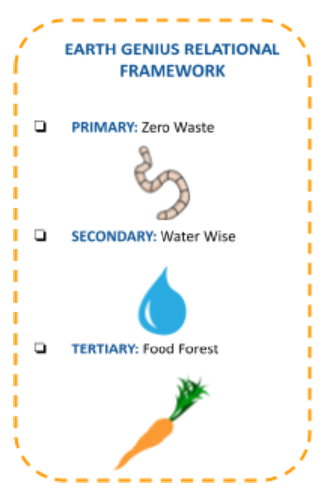

Lesson Bridge:

Connect this lesson (3) to ‘Living in our Watershed’ (2) by discussing how litter might travel throughout a watershed. Ask students how water might be able to move pollution into the ocean where it then becomes marine debris. Close the loop by connecting back to Lesson #1 (Is Soil Alive?) by discussing how certain microbes are unable to decompose certain types of waste.

Lesson Overview:
How is litter created? What impact does it have on the environment, both humans and non humans? In this lesson students pose questions about the nature of the litter found around their school, make predictions, do a campus cleanup to cultivate environmental stewardship, and then brainstorm solutions to prevent litter.

Suggested Activities and Learning Objectives by Grade Level:
- K:
  - K-ESS-3 How can we prevent litter?

Essential Question(s) that Connect CCCs and SEPs:
- How does what I observe and note on campus about pollution, habits, and structures for humans change at different scales? Can I think of examples of what I am seeing as bigger or smaller? (Scale; Asking Questions & Defining Problems)
- What is already known about this cause and effect? How can I best communicate about this cause and effect relationship? (To my peers, campus, through a PSA, class presentation, etc) (Cause & Effect; Obtaining, Evaluating, and Communicating Information)

Vocabulary:
Pollution-Something that has entered an environment or space and has a harmful effect
Litter-When trash gets left in the ground and not in the trash where it needs to be
Human Impact- The ways that humans actions affect the environment
Marine Debris- Trash, litter, or pollution that ends up in the oceans

Materials:
- Garden Journals TK/K, 1st/2nd (Optional)
- Ocean in a jar. A large plastic jar with water and different pieces of plastic trash in it, some that sink and some that float. You can use wrappers, bottle caps, labels, pieces of plastic bags, etc. Consider demonstrating a clean ocean in a jar as well, one that has sand and seashells and pieces of driftwood to show the difference.
- One 10 gallon bucket or trash bag
- Litter Grabbers if you have them
- Hand Sanitizer
- Compostable or reusable gloves
- Campus map (Optional: If needed, ask for a copy at the front office)

Prep:
- This lesson is to be done primarily outside. Figure out what route you will be taking beforehand and identify areas with a lot of litter. Make sure to include these on your tour.
- If it rains, have students look at campus maps and talk about possible areas of pollution from street/campus/community activities.
- Print out a Campus Cleanup Data Collection Sheet
- Print out any additional worksheets (found at the bottom of this lesson) that you would like students to work on.

Activity Procedure:
Engage:
Pass around your ocean in a jar with trash in it and ask kids to shake it up.

Explore:
What do you all notice about the objects inside? Are some on the top of the water and some on the bottom? Why is that (some float because they are lighter). What is all this stuff in the water? Have you ever seen trash in a creek before? Where does that trash go? (the ocean). Right now there is a lot of litter in the ocean.

Explain:
When people leave things in nature that are not supposed to be there such as cans and plastic wrappers, we call this littering. Littering isn’t good for the animals and plants that live in nature because sometimes they think they can eat the litter and then they get sick. Let me give you an example of how litter harms animals. Imagine there is a lizard who is searching for a warm home to stay dry in. Instead of finding her natural habitat, she discovers a bottle that has been littered on the ground. She thinks that a bottle would be a nice place to hang out in but then when she goes inside, she gets trapped and can’t get back out! Have you ever seen litter at your school? What are some examples of litter you can think of? What sorts of animals live at your school? (Birds, lizards, squirrels, etc). Imagine you are one of those animals. Would you like the litter or not? Why or why not? A lot of litter eventually makes its way into the ocean where it becomes something we call ‘marine debris.’ Can you say “marine debris?” Point to your dirty ocean in a jar to demonstrate marine debris. Define the remaining vocabulary words.
Action: Trash Pick-up Tour
- Review your Garden Agreements
- Explain to students that you are about to go on a campus trash pickup but in order to do so, we have to make sure that we are quiet and respectful.
- Go to areas of the campus where there is a lot of trash.
- Clean up litter and place it into your waste receptacle. For the younger students, it may be a good idea to have kids point out trash that they find, and you be the one to go and pick it up and properly dispose of it.
- Record the type of trash items that you find (wrappers, paper, etc) on your Campus Cleanup Data Collection Sheet
- See if you can separate recycling, compost and landfill waste.
- Dispose of waste into the proper receptacle.
- Dispose of gloves and wash hands with soap.
- If time allows, choose a Pollution Solutions worksheet for the students to work on (found at the bottom of this lesson in ‘Extension Activities’) or work through your garden journals.

Reflect:
What sort of litter did we find? What are things you can do to help stop litter at your school? Do you think if we hadn’t picked up this litter today, it would have made its way into the ocean as Marine Debris?

Extension Activities:
- Marine Debris Word Search
- Compost, Recycle, Trash Sorting Worksheet
- You Are What you Eat Marine Animal Cards
- Make colorful signs encouraging recycling and “zero waste” lunches with less packaging, and the connection of land-based litter to watershed/ocean pollution.
- Create mosaics by gluing found litter in the shape of marine life or other native animals with sayings that will remind other students not to litter.
- One Cool Earth’s Marine Debris Prevention Manual
- Spanish Lesson Plan

Cited Curriculum:
- Do the Rot Thing, Environmental Lunch (Page 8 has the template for documenting items found)
- MERITO Ocean Conservation & Education
  - One Cool Earth Directors were trained in the MERITO curriculum and have a partnership with this team in Southern California
- Ocean Conservancy Coastal Cleanup Data Card
- Spanish Lesson Plan

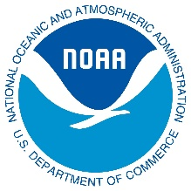

This lesson was prepared by One Cool Earth under award
NA20NOS4290033 from the Bay Watershed Education and Training Program
of the National Oceanic and Atmospheric Administration (NOAA), U.S.
Department of Commerce. The statements, findings, conclusions, and
recommendations are those of the author(s) and do not necessarily reflect
the views of NOAA or the U.S. Department of Commerce.

